Approval Signatures:

Department | Name | Signature | Date
QA | Scott Pletzer
OPS | Michael Stowell
Exec | Nancy Rizzo
IS | Andrew Mason

Revision History
Revision | Revision Date | Reason for Revision/Change Request | Revised By
006 | 31Jul12 | Version 1.1.1.4 of the ClearView software added the ability for the system to attempt to auto-reconnect to the scanner in the situation where a connection was lost. A new section was added to the script to test this feature in the ‘Device Testing’ section of ClearView. | A. Mason
007 | 30Aug12 | Revised to accommodate the testing requirements for the release of version 2.0. | A. Mason
008 | 04Sep12 | Changes made to script and software (now 2.0, release candidate B) to address nonconformances found during execution of protocol (Rev 007). | A. Mason
009 | 24Oct12 | Change to header/footer only to reflect protocol execution for version 2.1. No content changes to protocol. | A. Mason
010 | 31Oct12 | Updated protocol with minor script changes to address nonconformance #1 (protocol version 009) related to saving of patient demographics. | A. Mason

- Purpose
This document is intended to provide a protocol for use in validating the ClearView ™ software. This protocol is intended to provide a method for conducting the testing as well as to be used as a formal record of the validation activities.

- Scope
This protocol is intended to be used to fully validate the APPLICATION Icon portion of the ClearView software for use. The protocol can be executed in total or in part. Any deviation from performing all sections of this validation must be resolved with appropriate written justifications prior to final approval of the validation report.

- Definitions

N/A

- Responsibilities
User | - Complies with the policy and procedure.  - Ensures the most current version of this document is used when referenced.
Departmental Management | - Ensures departmental personnel are properly trained before using this policy or procedure.  - Provides oversight to the validation process and ensures that all quality system requirements are met.
Quality Assurance | - Monitors the implementation and effectiveness of this document.  - Audits to ensure compliance with the referenced procedures

- Policy
  - This protocol is intended to be updated for any changes made to the software such that the instructions provide a comprehensive test to demonstrate whether the software meets the intended use. Validation of the technical analyses and mathematical computations are completed under a separate protocol.
  - Follow the instructions provided within this protocol as written. Any deviations from the written protocol will be recorded on Attachment A, Deviations from Protocol.
    - An individual will be assigned responsibility from the Validation Team to oversee the execution of the protocol. This validation designee will review each deviation as documented prior to moving forward in the validation process.
    - The validation designee will be required to determine whether the deviation requires formal documentation through EPIC’s Deviation procedure or if the deviation is minor enough to warrant documentation only.
    - Upon completion of the protocol, the Validation Team has the responsibility to review all deviations recorded to determine whether or not they significantly impact the protocol/validation process. Any deviation deemed significant will be handled through EPIC’s Deviations procedure.
    - The individual performing the validation protocol will complete each column of Attachment A for all deviations from the written protocol prior to moving forward. The validation designee will review each deviation prior to moving forward in the validation process. This review is indicated by documenting a signature and date in the Review column of the Deviations from Protocol worksheet located in Attachment A.
    - The validation designee should be aware during the execution of this validation protocol that the intention is to validate all functionality of the APPLICATION Icon. If at any time a portion of the software is identified as not being challenged notify the validation team immediately and document the omission on the non-conformances worksheet.

  - The written protocol is intended to capture the steps needed to properly challenge each software function/data point. However, given the evolving nature of software development, the instructions may not be 100% accurate. Therefore, any minor deviation from the written instructions will be corrected in writing during the execution of the validation protocol. These corrections will be reviewed by QA as a part of the validation analysis. The review will determine appropriate corrective and preventive action for any deviations notes.

  - Record the results of each validation step by initialing and dating in the space provided. If the characteristic cannot be verified, record a reference number on the protocol and the Non-Conformances Worksheet (Attachment B) and describe the failure in a specific and complete manner by completing all columns on the Non-Conformance Worksheet. Some validation steps ask the validation designee to record the results side-by-side. In these cases, record initials and date on each side of the slash mark after validating each step as instructed.

  - ClearView Error Messages
The four acceptable error messages generated by the ClearView software are shown below. If any other error message is displayed during the execution of this protocol, describe and record the error on the Non-Conformances Worksheet.








- Procedure
  - Device Set Up
    - Verify with QA and IT that the correct ClearView software revision, license, database, and scanner have been installed on the test workstation.
    - Clean the glass lens with isopropyl alcohol and the provided cloth. Dry the glass lens completely with a separate dry cloth.
    - Place the calibration shroud over the lens cover.
    - Clean the metal cylinder of the calibration probe with isopropyl alcohol and the provided cloth. Dry the calibration probe completely with a dry cloth.
    - Place the calibration probe, metal cylinder first, through the opening of the calibration shroud until the bottom of the probe sits flat on the glass lens.
    - Double click on the ClearView software icon located on the computer desktop. This will open the ClearView software and present the “Login As” window.
    - The version of the ClearView software is displayed across the top header of the software. Record the software version being validated:

_______________________________________________________

  - “Login As” function- This window provides the user a method to enter their user name and password in order to access the ClearView software application.

Verify that the Username and Password box are empty.

Verified Not Verified Non-Conformance Ref. No.

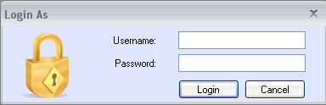

Click in the Username box and enter “Administrator”. Click in the password box and enter the password provided by the Network Administrator. Click the Cancel button. Verify that the “Login As” window and the ClearView software window close and returned to the computer desktop.

Verified Not Verified Non-Conformance Ref. No.

Double click on the ClearView software icon located on the computer desktop. Click in the Username box and enter “Administrator”. Click in the password box and enter the password provided by the Network Administrator. Click the Login button. Verify that the “Login As” window is closed and EPIC ClearView main screen for the ClearView software is displayed.

Verified Not Verified Non-Conformance Ref. No.

  - Application Functions
This section has four (4) buttons – Settings, Change Login, Update Login Info, and Exit.

    - Change Login Button- This button is used to open the “Login As” window in order to change users.

Click on the ClearView software Change Login button. Verify that the “Login As” window is displayed.
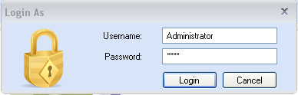

Verified Not Verified Non-Conformance Ref. No.

Click in the Username box and enter epicval and click in the password box and enter the 1234abc! as the password. Click the Login button. Verify that the Login Failed window with the message “Please enter valid Username and Password” appears.

Verified Not Verified Non-Conformance Ref. No.

Click OK. Verify that the Login As screen appears requesting user name and password.

Login as epicvalidation for the username and enter the password provided by the Network Administrator. Verify the main ClearView software screen appears.

Verified Not Verified Non-Conformance Ref. No.

    - Update Login Info Button- This button is used to open the Application User window in the UpdateUserForm tab in order to modify the user’s profile and login information.

Click the Update Login Info button. Verify that the UpdateUserForm tab opens with the epicvalidation user information displayed on the screen.

Verified Not Verified Non-Conformance Ref. No.
Verify the information below is correct for the user. If not, change any relevant information. Re-enter the password below for the user:

User Name epicvalidation (no change)
Click on Change Password:
Password epic5678!
Confirm Password epic5678!
First Name Epic
Middle Initial E
Last Name Administrator
E-mail a@b.com

Save the data entered by clicking the Disc Icon Save button in the upper left corner of the screen. Verify that the Save Successful box appears. Click the OK button. Verify that the ClearView main screen is displayed.

Verified Not Verified Non-Conformance Ref. No.

Click the Update Login Info button. Verify that the UpdateUserForm tab opens and the information modified in the previous step was saved completely. Click the “X” in the upper right corner of the UpdateUserForm tab. Verify that the dialog box closes, the UpdateUserForm tab closes, and the ClearView main screen is displayed.

Verified Not Verified Non-Conformance Ref. No.

Click on the Change Login button. Click in the Username box and enter “Administrator”. Click in the password box and enter the password provided by the Network Administrator. Click the Login button. Click Search User and enter “aclearview” in the User Name search box and click Find. Highlight the User Name “aclearview”, click the View User button. Uncheck the Enabled option if it is checked. Click the Save button in the upper left corner of the screen. Click OK.

Verified Not Verified Non-Conformance Ref. No.

Click on the Change Login button. Click in the Username box and enter “aclearview”. Click in the password box and enter the password provided by the Network Administrator. Click the Login button. Verify that the Login Failed box opens. Click the OK button and verify that the Login As box appears. Click the Cancel button. Verify that the ClearView main screen appears.

Verified Not Verified Non-Conformance Ref. No.

Click Search User and enter “aclearview” in the User Name search box and click Find. Highlight the User Name “aclearview”, click the View User button. Select the Login Enabled option. Click the Save button in the upper left corner of the screen. Click OK.

Verified Not Verified Non-Conformance Ref. No.

Click on the Change Login button. Click in the Username box and enter “aclearview”. Click in the password box and enter the password provided by the Network Administrator. Click the Login button. Verify that the ClearView main screen appears.

Verified Not Verified Non-Conformance Ref. No.

Click on the Change Login button. Click in the Username box and enter “epicvalidation”. Click in the password box and enter the password as modified above. Click the Login button. Verify that the ClearView main screen appears.

Verified Not Verified Non-Conformance Ref. No.

    - Exit Button- This button is used to exit and close the ClearView software system.

Click the Exit button. Verify that the ClearView software application closes and the screen returns to the computer desktop.

Verified Not Verified Non-Conformance Ref. No.

    - Settings Button – Device Settings tab This tab is used to change the camera settings in the ClearView software.

Login as Administrator with the password provided by the Network Administrator. Verify that the ClearView main screen appears. Click on the Settings button. Verify that the Settings tab opens.
Verified Not Verified Non-Conformance Ref. No.

Note: Many of the steps in this section will be performed on one scanner and repeated on another. The actual serial number of the scanner will be recorded on the printouts, and the filenames will be differentiated by the suffix A or B.
In the Device Settings section, complete the four device configuration lines with the following values:
Brightness | Gain | Exposure Delay | Boost Voltage | Default
90 | 63 | 320 | 100% | Checked
85 | 62 | 320 | 103% | Unchecked
80 | 61 | 150 | 107% | Unchecked
75 | 30 | 310 | 110% | Unchecked

Click the Apply Settings button. Click on the Calibration icon. Verify that the Settings tab closes and the screen returns to the ClearView main screen.
Verified Not Verified Non-Conformance Ref. No.

Click on the Settings button. Verify the settings above were saved and record the Settings results below.
Brightness | Gain | Exposure Delay | Boost Voltage | Default

Click the Apply Settings button. Click the “-” in the upper right corner of the screen to minimize ClearView. Click on the Camera Properties icon. Click on the Picture tab. The Properties window should appear as shown below.

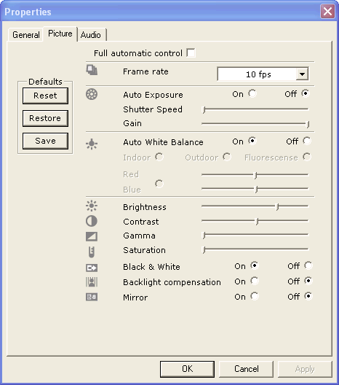

Using a clipping tool or SnagIt, capture the image of the Picture tab of the Properties window and save as the following file: O:\QualitySystems\Quality_System_Documents\Non-quality_system_records\CV_Validation\BrightnessImages\PropB90G63A. Print this file and label with the filename and serial number of the scanner, initial and date, and attach to the end of this protocol. Click on the ClearView tab in the taskbar to restore ClearView.

Verified Not Verified Non-Conformance Ref. No.

Click the Start Duty Cycle Testing button. Allow the scanner to take two or three images and click the Stop Duty Cycle Testing button to stop. Using a clipping tool or SnagIt, capture the image of the Camera Calibration window and save as the following file: O:\QualitySystems\Quality_System_Documents\Non-quality_system_records\CV_Validation\BrightnessImages\B90G63A.
In the Calibration Settings Group Box in the center of the dialog, click on the “Configuration 4” radio button. Verify that image in the Image Preview window is noticeably dimmer (this may take up to 10 seconds)..
Verified Not Verified Non-Conformance Ref. No.

Click the Start Duty Cycle Testing button. Allow the scanner to take two or three images and click the Stop Duty Cycle Testing button to stop. Verify that images captured during duty cycle are significantly dimmer than the images captured in duty cycle using “Configuration 1”. Using a clipping tool or SnagIt, capture the image of the Camera Calibration window and save as the following file: O:\QualitySystems\Quality_System_Documents\Non-quality_system_records\CV_Validation\BrightnessImages\B75G30A.

Verified Not Verified Non-Conformance Ref. No.

Click the “-” in the upper right corner of the screen to minimize ClearView. Click on the Camera Properties icon. Click on the Picture tab. The Properties window should appear as shown below, with the gain slider should be approximately in the middle. Using a clipping tool or SnagIt, capture the image of the Camera Properties window and save as the following file: O:\QualitySystems\Quality_System_Documents\Non-quality_system_records\CV_Validation\BrightnessImages\PropB75G30A.

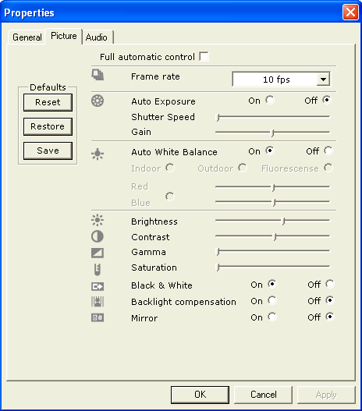
Click on the ClearView tab in the taskbar to restore ClearView.
Click on the “Configuration 3” radio button. (this may take up to 10 seconds). Click on the Duty Cycle button and verify that either blank or very dim images are captured due to the shorter Exposure Delay setting. Using a clipping tool or SnagIt, capture the image of the Scanner Calibration window and save as the following file: O:\QualitySystems\Quality_System_Documents\Non-quality_system_records\CV_Validation\BrightnessImages\Delay150.
Verified Not Verified Non-Conformance Ref. No.

Click the Close button in the Calibration Dialog window and verify that the Calibration Dialog window closes and the ClearView. Verify that the calibration tab closes and the screen returns to the ClearView main screen.

Exit out of the ClearView application and attach a new scanner.

Connect a different scanner for the remainder of this section.
Sign into ClearView as an administrator. Click on the Settings icon. Verify the settings are the same as the four settings from section 6.3.4. Click the Apply Settings button. Click on the Calibration icon. Click the “-” in the upper right corner of the screen to minimize ClearView. Click on the Camera Properties icon. Click on the Picture tab. The Properties window should appear as shown below.

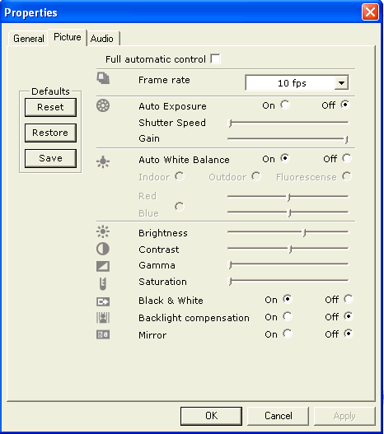

Using a clipping tool or SnagIt, capture the image of the Picture tab of the Properties window and save as the following file: O:\QualitySystems\Quality_System_Documents\Non-quality_system_records\CV_Validation\BrightnessImages\PropB90G63B. Print this file and label with the filename and serial number of the scanner, initial and date, and attach to the end of this protocol. Click on the ClearView tab in the taskbar to restore ClearView.

Verified Not Verified Non-Conformance Ref. No.

Click the Start Duty Cycle Testing button. Allow the scanner to take two or three images and click the Stop Duty Cycle Testing button to stop. Using a clipping tool or SnagIt, capture the image of the Camera Calibration window and save as the following file: O:\QualitySystems\Quality_System_Documents\Non-quality_system_records\CV_Validation\BrightnessImages\B90G63B.
In the Calibration Settings Group Box in the center of the dialog, click on the “Configuration 4” radio button. Verify that image in the Image Preview window is noticeably dimmer (this may take up to 10 seconds)..
Verified Not Verified Non-Conformance Ref. No.

Click the Start Duty Cycle Testing button. Allow the scanner to take two or three images and click the Stop Duty Cycle Testing button to stop. Verify that images captured during duty cycle are significantly dimmer than the images captured in duty cycle using “Configuration 1”. Using a clipping tool or SnagIt, capture the image of the Camera Calibration window and save as the following file: O:\QualitySystems\Quality_System_Documents\Non-quality_system_records\CV_Validation\BrightnessImages\B75G30B.

Verified Not Verified Non-Conformance Ref. No.

Click the “-” in the upper right corner of the screen to minimize ClearView. Click on the Camera Properties icon. Click on the Picture tab. The Properties window should appear as shown below, with the gain slider should be approximately in the middle. Using a clipping tool or SnagIt, capture the image of the Camera Properties window and save as the following file: O:\QualitySystems\Quality_System_Documents\Non-quality_system_records\CV_Validation\BrightnessImages\PropB75G30. Print and label the Camera Properties page and attach it to the end of the protocol.

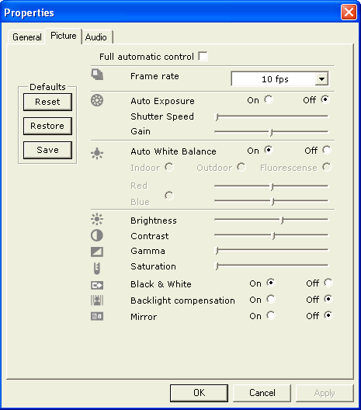
Click on the ClearView tab in the taskbar to restore ClearView.
Click on the “Configuration 3” radio button. (this may take up to 10 seconds). Click on the Duty Cycle button and verify that either blank or very dim images are captures due to the shorter Exposure Delay setting. Using a clipping tool or SnagIt, capture the image of the Scanner Calibration window and save as the following file: O:\QualitySystems\Quality_System_Documents\Non-quality_system_records\CV_Validation\BrightnessImages\Delay150B.
Verified Not Verified Non-Conformance Ref. No.

Click the Close button in the Calibration Dialog window and verify that the Calibration Dialog window closes and the ClearView. Verify that the calibration tab closes and the screen returns to the ClearView main screen.

Click Application Change Login icon. Verify that the Login As box appears.
Verified Not Verified Non-Conformance Ref. No.

Click Cancel. Verify that the ClearView main screen appears.

Verified Not Verified Non-Conformance Ref. No.

Click Applications Update Login Info button. Verify that the UpdateUserForm tab opens.
Verified Not Verified Non-Conformance Ref. No.
Click the “X” in the upper right corner of the UpateUserForm tab. Verify that the tab closes and the ClearView main screen appears.

Verified Not Verified Non-Conformance Ref. No.

Scanner and Camera Status
At the bottom of the screen, verify that the Scanner Status is Available and the Camera Status is Available. Unplug the USB cable from the scanner. After a few seconds of delay, verify that the Scanner Status and Camera Status change to Unavailable.

Verified Not Verified Non-Conformance Ref. No.

Reconnect the USB cable to the scanner. After a few seconds of delay, verify that the Scanner Status and Camera Status change to Available.

Verified Not Verified Non-Conformance Ref. No.

    - Settings Button – Device Testing tab This tab is used to test camera functions in the ClearView software.

Click on the Application Settings button. Click on the Device Testing tab. Verify the Device Testing tab opens and appears as shown:

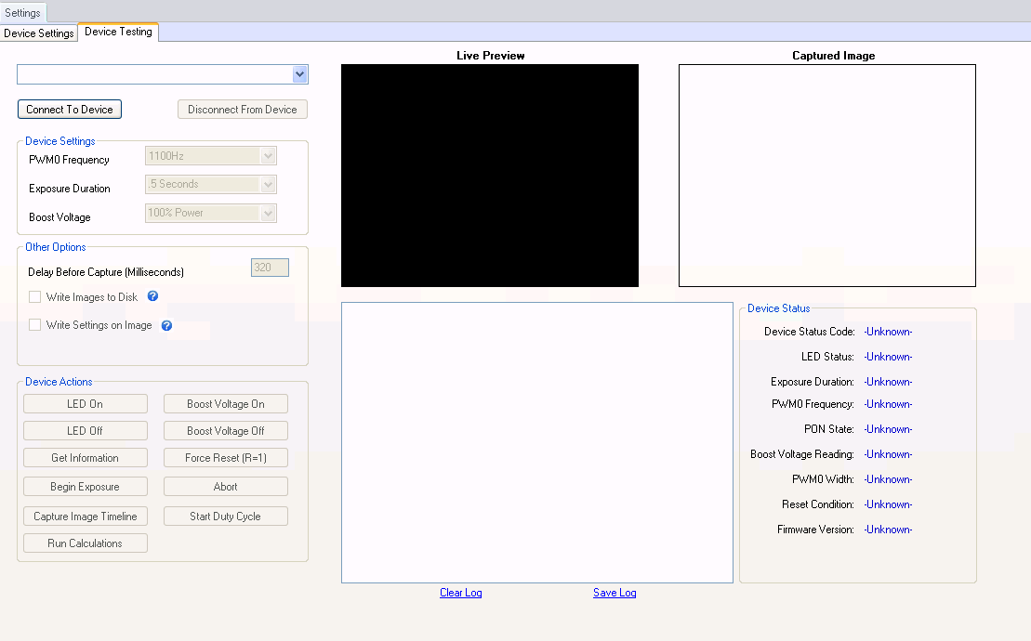

Verified Not Verified Non-Conformance Ref. No.

Click on the Connect to Device button. Verify the “A camera must be selected” dialog box opens. Click OK. Verify the dialog box closes.

Verified Not Verified Non-Conformance Ref. No.

In the dropdown menu, select the Phillips SPC 900NC PC Camera. Verify it is highlighted in the dropdown window. Click on the Connect to Device button. Verify the grayed out fields become active and the Log shows entries. Verify the Disconnect from Device button becomes active.

Verified Not Verified Non-Conformance Ref. No.

Click on the Disconnect from Device button. Verify the active fields become grayed out and the Connect to Device button becomes active. Click on the Connect to Device button. Verify the fields are active.

Verified Not Verified Non-Conformance Ref. No.

In the Device Settings section, select each option in each dropdown and verify it appears in the dropdown window, end by selecting the original values of 1100Hz, .5 Seconds, and 110% Power.

Verified Not Verified Non-Conformance Ref. No.

In the Exposure Duration dropdown, select the .5 Seconds option. Click the Begin Exposure button in the Device Actions section and verify the duration of the tone generated is approximately .5 seconds. Repeat for the remaining values of 1, 2 and 30 seconds. Select the .5 seconds option and click Begin Exposure.

Verified Not Verified Non-Conformance Ref. No.

In the Device Actions section, Click on the LED On button. Verify a live image of the calibration probe appears in the Live Preview box. Click on the LED Off button. Verify the image disappears.

Verified Not Verified Non-Conformance Ref. No.

Click on the Get Information button. Verify the entries in the Device Status section reflect appropriate values. Record the last entry, Firmware Version, below:

Verified Not Verified Non-Conformance Ref. No.

Click on the Begin Exposure button. Verify an energized image appears briefly in the Live Preview box, and an image appears and remains in the Captured Image box.

Verified Not Verified Non-Conformance Ref. No.

Click on the Boost Voltage On button. Click on the Begin Exposure button. Verify an image of similar brightness to the previous step appears in the Captured Image box.

Verified Not Verified Non-Conformance Ref. No.

Click on the Boost Voltage Off button. Click on the Begin Exposure button. Verify a dim image appears in the Captured Image box. Click on the Boost Voltage On button.

Verified Not Verified Non-Conformance Ref. No.

Click on the Force Reset button. Verify in the Log display a “Sending: R=1” entry displays followed by a “Received: “ entry.

Verified Not Verified Non-Conformance Ref. No.

Click on the Abort button. Verify in the Log display a “Sending: a” entry displays followed by a “Received: “ entry.

Verified Not Verified Non-Conformance Ref. No.

Click on the Start Duty Cycle button. Verify the energized images repeat in the Live Preview and Captured Image boxes at short intervals. Verify the Start Duty Cycle button now reads Stop Duty Cycle. Click the Stop Duty Cycle button. Verify the image taking stops, and the button now reads Start Duty Cycle.

Verified Not Verified Non-Conformance Ref. No.

Click the LED Off button and verify that a blank image appears in the Live Preview window.

Verified Not Verified Non-Conformance Ref. No.

In the Other Options section, change the value in the Delay Before Capture to 200. Click the Begin Exposure button. Verify the image in the Captured Image box is either not present or significantly dimmer than the original 320 setting. Change the value back to 320.

Verified Not Verified Non-Conformance Ref. No.

Next to the Write Images to Disk checkbox, hover over the question mark in the blue circle, and verify a pop-up message appears that reads “Checking this box will cause all captured images to be written to the same folder the app is being run in.”

Verified Not Verified Non-Conformance Ref. No.

Next to the Write Settings on Image checkbox, hover over the question mark in the blue circle, and verify a pop-up message appears that reads “Checking this box will cause the captured images to have the voltage and frequency used transposed on them.”

Verified Not Verified Non-Conformance Ref. No.

Click to check the Write Images to Disk checkbox. Click the Begin Exposure button. Navigate to folder C:\Program Files (x86)\EPIC\ClearView. Verify the file SampleImage0.gif appears in the folder with the correct date and time listed. Open the file, and verify it matches the image taken.

Verified Not Verified Non-Conformance Ref. No.

Click to check the Write Settings on Image checkbox. Click the Begin Exposure button. Verify the new image in the Captured Image box has the Voltage and Frequency written in the box. Navigate to folder C:\Program Files\EPIC\ ClearView. Verify the file SampleImage1.gif appears in the folder with the correct date and time listed. Open the file, and verify it matches the image taken.

Verified Not Verified Non-Conformance Ref. No.

Click to uncheck the Write Images to Disk checkbox. Click the Begin Exposure button. Verify the new image in the Captured Image box has the Voltage and Frequency written in the box. Navigate to folder C:\Program Files\EPIC\ Clearview. Verify a new file was not saved in the folder.

Verified Not Verified Non-Conformance Ref. No.

Verify that there are entries in the Log window. Click on the Save Log link below the window. A save dialog will appear. Create a filename of devicetestinglog(software version; e.g. 2.1).txt and a path of O:\QualitySystems\Quality_System_Documents\Non-quality_system_records\CV_Validation. Click on the Save button to save the file. A dialog should appear stating that the file was saved. Click on the OK button to close the dialog.

Verified Not Verified Non-Conformance Ref. No.

Navigate to folder O:\QualitySystems\Quality_System_Documents\Non-quality_system_records\CV_Validation and verify that the file. Verify the file “devicetestinglog(software version; e.g. 2.1).txt“ appears in the folder with the correct date and time listed.

Verified Not Verified Non-Conformance Ref. No.

Under the Log window, click the Clear Log link. Verify all entries in the Log window disappear.

Verified Not Verified Non-Conformance Ref. No.

Click the “Disconnect From Device” button to disconnect the scanner. Click on the “X” in the upper right corner to close the Settings dialog. Verify that the ClearView main screen appears.

Verified Not Verified Non-Conformance Ref. No.

    - Customer User and Admin modes

Click the Exit icon in the upper right hand corner of the screen. Verify that the EPIC ClearView is closed and the desktop now appears.

Verified Not Verified Non-Conformance Ref. No.

Customer User
Double click the EPIC ClearView icon on the desktop. Enter the user name as “clearviewuser” and the password provided by the Network Administrator. Verify that the ClearView main screen appears and the User Options icon and the Settings icon are not displayed on the Application tool bar at the top of the page.

Verified Not Verified Non-Conformance Ref. No.
Customer Admin
Click Application Change Login icon. Verify that the Login As box appears. Enter the user name as “epicvalidation” and the password as modified in section 6.3.2. Verify that the ClearView main screen appears and the User Options icon appears in the main tool bar.
Verified Not Verified Non-Conformance Ref. No.
Click Application Update Login Info. Verify that the Login Info box appears. Click the “X” in the upper right corner of the UpdateUserForm tab. Verify that the ClearView main screen appears.
Verified Not Verified Non-Conformance Ref. No.

Click the Exit button.

  - Techadministrator

Double click on the ClearView software icon located on the computer desktop. Click in the Username box and enter “techadministrator”. Click in the password box and enter the password provided by the Network Administrator. Click the Login button. Verify the EPIC ClearView main screen is displayed and the User Options icons and the Settings icon are displayed.

Verified Not Verified Non-Conformance Ref. No.

Click on the Camera Calibration button. Verify the Calibration tab opens. Verify the Start Duty Cycle Testing and Reset Images buttons are present and enabled. Right-click in the Calibration Image boxes and load a set of known passing calibration images and click on the Submit Calibration button. Verify the calibration passes and saves the images to the path of C:\Temp\ClearView\Calib_Results folder.

Verified Not Verified Non-Conformance Ref. No.

Click on the New Capture button. Verify the Search Patient tab opens. Find subject Epic Validation and click on the New Capture button. Verify that the Pre-Scan Question dialog apprears.

Verified Not Verified Non-Conformance Ref. No.

Answer all 3 questions with “NO” and click the OK button on the Pre-Scan Question dialog and verify that the Gather Capture screen appears.

Verified Not Verified Non-Conformance Ref. No.

Verify there is no Export Images button in the New Capture window. Right-click in each Finger Image box and verify no Open dialog appears. Click the Close button, then Yes, to return to the ClearView main screen.

Verified Not Verified Non-Conformance Ref. No.

Click on the Search Capture button. Find a Treatment for subject Epic Validation and click on the View Capture button. Verify the View Capture tab opens. Verify there is no Resubmit Images for Analysis button. Click the Close button to return to the ClearView main screen.

Verified Not Verified Non-Conformance Ref. No.

Click on the Search Capture button. Find a Treatment for subject Epic Validation and click on the View Report button. Verify that two tabs appear. The first tab being “Report for EPIC Validation” and the second being “Print Report for EPIC Validation”. Verify the Admin tab is not present.

Verified Not Verified Non-Conformance Ref. No.

Click the “X” in the upper right corner of each tab displayed until the ClearView main screen appears. Click on the Settings button. Verify the Settings tab opens with the Device Settings subtab highlighted. Click on the Device Testing tab. Verify the Device Testing tab opens. Verify functionality by clicking several buttons and checking for responses. Click the “X” in the upper right corner of the Settings tab to return to the ClearView main screen. Click the Exit button to exit ClearView.

Verified Not Verified Non-Conformance Ref. No.

  - Audit Trail

Log in as “EPICUser”. Click on the “Manage Patient” button, then click the “Find” button and the Search dialog appears. At the bottom of the Search dialog, click the New Patient button. Verify that the New Capture button contained in the Add Patient window is not enabled.

Verified Not Verified Non-Conformance Ref. No.

Add a new user with the name User A Audit, birthdate of 7/7/77, and Gender is Male. Click the Save button and verify that Save Successful dialog window appears. Click OK to close the window. Note the user ID, time (located in the lower left corner of the ClearView software screen) and date of the save below:

Original
User: Date: Time:

Exit out of ClearView, restart ClearView and log back in as “administrator”. Under Manage Patient, search for patient with last name Audit, located record just entered, and select View Patient. Modify subject User A Audit to Admin B Audit, birthdate to 8/8/88, and Gender to Female. Click the Save button and verify that Save Successful dialog window appears. Click OK to close the window. Note the user ID, time (located in the lower left corner of the ClearView software screen) and date of the save below:

Modified
User: Date: Time:

Obtain a printout from the Network Administrator showing the audit trail for subject Admin B. Audit and verify it shows the user who made the entries, the date and time of the saves, and the values changed. Verify the audit trail results match the data entry from #1 and #2 above. Sign and date the audit trail printout and attach the printout to the end of this protocol.

Verified Not Verified Non-Conformance Ref. No.

Exit out of ClearView, restart ClearView and Login as “EPICUser”. Perform an Auto Calibration and record the date and time (located in the lower left corner of the ClearView software screen) of the successful calibration below:

Calibration
User: Date: Time:

Perform a New Capture for subject Admin B. Audit. Record below the date and time the Submit for Analysis button was clicked and the date and time (located in the lower left corner of the ClearView software screen) the process completed successfully and the ClearView Report displayed, the Treatment ID listed in the RawData tab, and the Firmware version listed in the Worksheet tab.

User:

Submit Date: Time:

Completion Date: Time:

Treatment ID

Firmware version

Exit out of ClearView, restart ClearView and Login as “administrator”. Perform a Resubmit for subject Admin B. Audit and the Treatment ID listed above. Record below the date and time(located in the lower left corner of the ClearView software screen) the Resubmit for Analysis button was clicked and the date and time the process completed successfully and the ClearView Report displayed, the Treatment ID listed in the RawData tab, and the Firmware version listed in the Worksheet tab.

User:

Submit Date: Time:

Completion Date: Time:

Treatment ID

Firmware version

Obtain a printout from the Network Administrator showing the audit trail for subject Admin B. Audit and verify it shows the user who performed the functions (including calibration, patient image capture, raw data processed and report data processed), the date and time of the functions, and the Firmware version. Verify the audit trail results match the data entry from #3 and #4 above. Sign and date the audit trail printout and attach the printout to the end of this protocol. Record Pass or Fail in the appropriate column of the following table. If the verification fails, record the non-conformance number next to Fail in the table. Initial and date next to the recorded result. Exit out of ClearView.

Test | Calibration Images | Patient Images | Raw Data Processed | Report Data Processed
#3- New Capture
#4- Resubmit

  - License File

Right click on the ClearView icon on the desktop and click on Properties. A Properties window will open. Navigate to the folder identified in the “Start in:” field. Rename the file “ClearView.lic” to “ClearViewA.lic”. Double click on the ClearView software icon located on the computer desktop. Verify the “No valid license file was found” error box appears. Click OK. Rename the file “ClearViewA.lic” back to “ClearView.lic”. Double click on the ClearView software icon located on the computer desktop. Click in the Username box and enter “administrator”. Click in the password box and enter the password provided by the Network Administrator. Click the Login button. Verify the EPIC ClearView main screen is displayed.

Verified Not Verified Non-Conformance Ref. No.

  - Automatic Logout

Note the time. Do not perform any work in ClearView. After 10 minutes, verify a message appears at the bottom of the screen next to an exclamation mark in a blue circle that reads. “System will close in 5 minutes, due to inactivity.”

Verified Not Verified Non-Conformance Ref. No.

Verify that after 5 minutes, ClearView automatically closes and the desktop appears.

Verified Not Verified Non-Conformance Ref. No.

  - Failed Login

Double click on the ClearView software icon located on the computer desktop. Click in the Username box and enter “EPICUser”. Click in the password box and enter the “guess”. Click the Login button. Verify the Login Failed message appears. Click OK. Repeat for a second and third attempt. Note the time after the third attempt.

Time:

Attempt to login for a fourth time using the correct password. Record the time attempted:

Time:

Verify the same error message appears.

Verified Not Verified Non-Conformance Ref. No.

Wait 30 minutes from the third failed login, attempt to login with the correct password. Record the time attempted:
Time:

Verify login is successful.

Verified Not Verified Non-Conformance Ref. No.

  - Automatic Reconnection Attempts

The ClearView software now has the capability to potentially automatically reconnect to the scanner in the event that the communication link between the computer and the scanner are lost. *** This does not include the disconnection event that occurs when USB cables are physically removed; physical removal of cables should not be done during this test of at any other time.

Log into the ClearView application as ‘Administrator’ and click on the ‘Settings’ button. A dialog with two tabs should display, click on the tab labeled ‘Device Testing’. Verify that that content of the tab appears.

Verified Not Verified Non-Conformance Ref. No.

Select the appropriate device from the drop down in the upper right hand area of the screen. Click the ‘Connect To Device’ button and verify that the connection completed and there is an image in the live preview window.

Verified Not Verified Non-Conformance Ref. No.

Click the ‘Start Duty Cycle’ button and verify that at least 10 images are captured successfully, by watching for the images to appear in the ‘Captured Image’ window.

Verified Not Verified Non-Conformance Ref. No.

With the duty cycle process still running reach around to the back of the scanner and flip the power switch up (to the off position) right after an energization event occurs. Verify that no sound is heard after that indicating that the device is no longer receiving commands. You should also see the words “Performing reconnect” in the message log box.

Verified Not Verified Non-Conformance Ref. No.

Now flip the power switch down (turning the scanner back on) and wait for about 10 -30 seconds. Verify that images are again being captured by the duty cycle process.

Verified Not Verified Non-Conformance Ref. No.

Stop the duty cycle process, Disconnect from the device and exit out of the ClearView application.

  - Manage Account

Log into the ClearView application as ‘EPICUser’ and verify that the Manage Account button is not present.

Verified Not Verified Non-Conformance Ref. No.

Exit out of ClearView, restart ClearView and Login as “EpicAdministrator” and verify that the Manage Account button is present and enabled.

Verified Not Verified Non-Conformance Ref. No.

- Reference
N/A

- Attachments
Attachment A, Deviations from Protocol
Attachment B, Non-conformances Worksheet

Attachment A
Deviations from Protocol
NOTE: This form is used for minor deviations from the protocol as written. Fill out all sections of this form prior to moving forward in the validation process.

No. | Date | Name | Description of Deviation (include reference to the protocol section) | Resolution/Action Taken | Reviewed
Attachment B - Non-conformances Worksheet
NOTE: This form is used for all protocol steps which did not perform as expected. Fill out all sections of this form prior to moving forward in the validation process.
No. | Date | Name | Description of Non-conformance (include reference to the protocol section) | Resolution/Action Taken

